 Transaction Validation Rules

Investigation Exercise

Create a transaction validation rule named "Observation Rule". Cut and paste the following code into the Rules Condition pane. Then, answer the question below.

transactionSet.Claim.LossType == "PR"

1. Under what circumstances will this rule execute? Write your explanation as if you were discussing the issue with a non-technical claims adjuster.

2. Cut and paste the following incomplete line of code into the Rules Action pane. Then, complete the code so that it displays a warning with the text message "Payments cannot be made on this type of claim." What is the complete line of code?
transactionSet.reject( /* fill in the parameters */ )

3. Test your answer by logging on to ClaimCenter as Ronald Barnes (rbarnes) and creating a new reserve line on any claim he has access to.
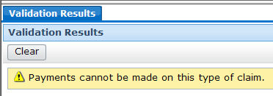

4. The validation rule is a warning about payments. Why does it display when you create a reserve line?
Can you add the reserve anyway? Go ahead and complete the reserve transaction.

5. Now, modify the code in the Rule conditions pane so that the rule action executes only if the transactionSet contains payment transactions. Also modify the line of code in the Rules Action pane so that it displays an error with the same text message. What is the correct code?

6. Test your answer by creating a new reserve line on a Ronald Barnes claim, and then by creating a payment against the reserve created above. What happens?
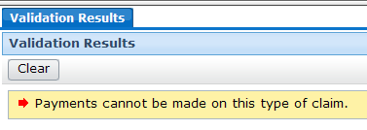

Configuration Exercise

Configure ClaimCenter to meet the following customer requirement from Acme Insurance.

Requirement 1: Preventing Indemnity Payments on Flagged Claims

As you may recall, claim exception rules are run periodically to identify claims that "require attention". When a claim requires attention, it is usually flagged. This creates a visual cue for the supervisor, who is responsible for reviewing the claim, attending to the issue, and then removing the flag.

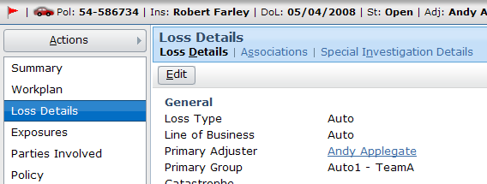

Acme Insurance does not want payments to be made on a flagged claim, as the issue creating the flag could alter the payment or even make it unnecessary.

7. Create the rule(s) needed to enforce these behaviors:
- A user cannot make an Indemnity payment on a flagged claim.

8. The ClaimCenter implementation team has provided additional notes:
- The error message should read "You cannot create indemnity payments on flagged claims."
- The requirements document does not specify how to identify that a claim is flagged. However, you should be able to determine this simply by reviewing the data dictionary.

Test Cases: Requirement 1

When you have completed your configuration, run the following test case:

9. Log on to ClaimCenter as Andy Applegate. Navigate to a flagged claim. (The Desktop Claims list identifies all claims assigned to Andy. The claim flag icon appears in the first column of this list for claims that have been flagged.) If you don’t see any Flagged claims, do a search for Claim # 235-53-365870 and assign it to Andy Applegate. If the claim and at least one of its exposures is not at Ability to Pay, then bring the claim and at least one of its exposures to Ability to Pay.

10. Attempt to create an indemnity payment on the claim. This should fail.

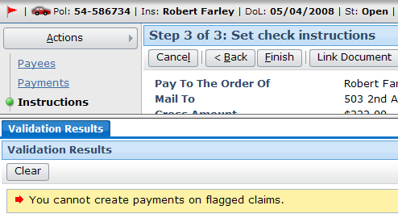

11. Backup in the Check Wizard and change to create an expense payment on the claim. This should succeed.

Requirement 2: Prevent the Voiding of Issued Checks

Acme Insurance issues payments through the Millennium Mutual bank. The agreement between the two companies is that once a check has been issued a check number, it cannot be voided. At this point, Acme Insurance must request a stop payment on the check.

12. Create the rule(s) needed to enforce these behaviors:
- A user cannot void a check with a check number.
- The Check Number field should be visually tagged by the error

13. The ClaimCenter implementation team has provided additional notes:
- To determine if a user is attempting to void a check, you should check to see if the check's status is being changed. However, keep in mind that the "Voided" status is determined by the external check processing system. To prevent the voiding of a check within ClaimCenter, you must look for a status which is assigned by ClaimCenter.

Test Cases: Requirement 2

When you have completed your configuration, run the following test case:

14. Log on to ClaimCenter as Andy Applegate. Using any claim on which payments can be made, create two manual checks. (See the next page for an overview of how to create manual checks.) Make sure that the first check has no check number and the second check has a check number.

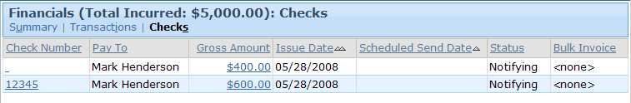

15. After the checks has been created, attempt to void both checks. (See the next page for an overview of how to void checks.) Verify that only the check with no check number can be voided.

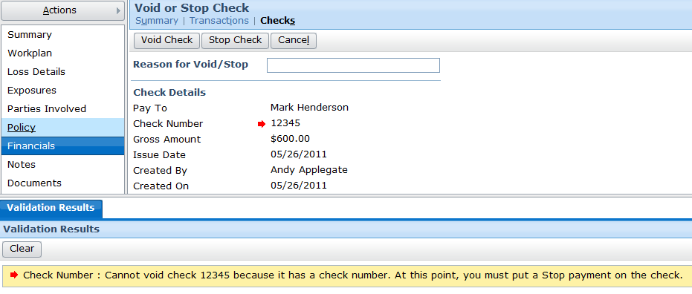

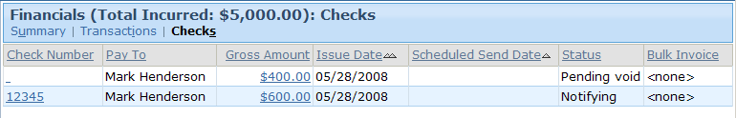

How To Create a Manual Check with a Check Number

1. Select New Transaction | Other | Manual Check.
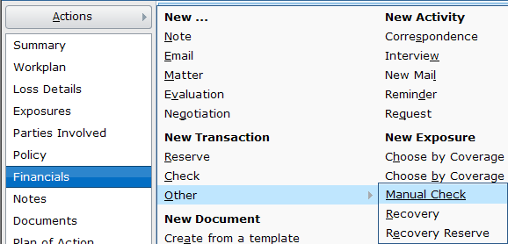

2. In step 1, specify a check number. Otherwise, complete the wizard as if it was a regular check.
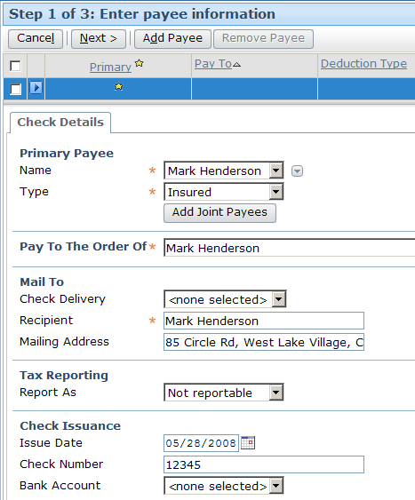

How To Void a Check

1. From the Transactions list, click the Check Number cell for the check.

2. In the Check Details screen, click "Void/Stop".
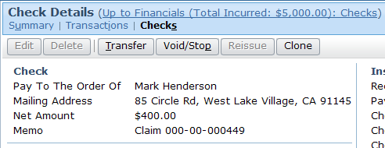

3. In the Void or Stop Check screen, click "Void Check".
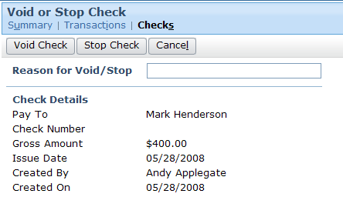

4. If the voiding is successful, the Status changes to "Pending void".
